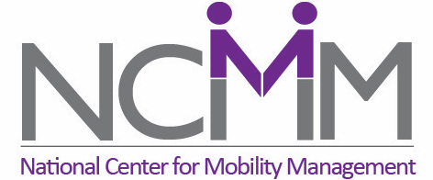
The National Center for Mobility Management (NCMM) is now accepting applications for our 2024 Ready-to-Launch Grants. These planning grants offer up to $75,000 in funding plus technical support from NCMM throughout the process. The goal of the grants is to enable multi-sector community teams to pilot promising mobility solutions, the development of which was inspired and informed by the results of community research. Applications are due by 11:59 pm ET on November 17th, 2023.

Ready-to-Launch Grants allow communities to pilot an innovative transportation solution that will allow underserved community members to become more fully engaged in economic opportunities, improve their health and well-being, and/or become more integrated into their community. NCMM will guide communities in using this pilot opportunity to test and confirm the feasibility of innovative transportation solutions in real-world application and will assist communities in preparing to seek funding for a full-scale roll-out of their solutions.

NCMM has funded 14 pilot projects since 2019. One of our grantees in Washington recently reached out to us, saying: “I just wanted to again thank you and NCMM for kickstarting our pilot. The pilot factored greatly into the decision of WSDOT to fund us!”

For any questions, reach out to reckley@ctaa.org. All answers will be posted at nationalcenterformobilitymanagement.org/ready-to-launch-grants-2024/.

NCMM is excited to learn about the innovative, community-centered projects that you have designed. So, reach out to your team, start your application, and get ready to pilot your program!

